In-Game Advertising – Sponsoring a Cup Event

Cup Events are the most prestigious form of racing in the virtual Track King world, and are guaranteed to grab the attention of every Stable Owner that is racing in the area/s that you target.

Additionally, permanent records of past and present Cup Events are available to all Track King gamers, which ensures that your advertising will continue to be visible long after your Cup Event has been run and won!

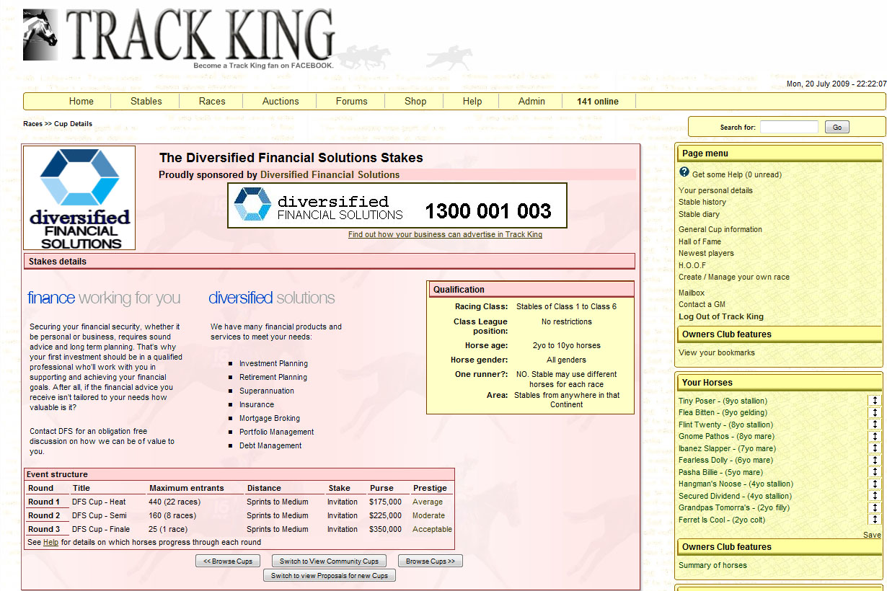

Get Creative!
First and foremost, you'll want a theme for the Cup! That may be your business name, or maybe something completely different. The actual name for the Cup event itself can be a total of 40 characters long.

Each round also bears a distinct name, such as "The My Cup heats" or "The My Cup Final". The round name is flexible, does not need to be exactly the same as the Cup event name, and is limited to 28 characters per round. You'll also need to consider/supply a "blurb" for the Cup to put on the Cup page itself (this can include HTML & images & limited javascript/flash). In the case of images/flash, we ask that all images used fit within a 400 x 500 block. Text/HTML code is limited to approximately 5,000 characters, and we ask only that the end result is "in keeping" with the site itself. (See above for example)

How to book
Once you've decided on a format you'd like, simply fill out some details on this form, and then email to advertising@TrackKing.org. Please note that although we'll try to be flexible and accommodating, 'balance' in the game is of utmost importance and hence some negotiation may need to occur.

What is the name of your Business?
What is the URL (web address) of your business’ website?
Will you require creatives/graphics to be made for your event?
What would you like your Cup Event to be known as? (e.g. The Jack Smith Open, The Jack Smith Plate, The Jack Smith Cup etc) | (40 character limit)
What is the desired ‘scope’ of your Cup Event? | (Supply full details of the demographic to target)
How many weeks should your Cup Event run for? | (1 weekend minimum, 4 weekends maximum)
Is there a preferred time of year/frequency to advertise? | (4 times a year maximum frequency, most weekends available)
Do you have any particular specifications about the format or qualifications for this event?  - Horse: Age (2-10yo), Gender;  - Stable: Class (1-6), League pos (1-25);  - Runners per race: (1-25);  - Gender: Stallions, mares, geldings?  - Nationalities: Players identify as a given nationality only  - Apprentices ride only?  - Owner/Breeder horses only?  - Less that a given rating/earnings?  - Format: How many qualify/progress?  - Stakes to enter the race? | (Leave blank if no particular requirements)
e-mail to advertising@trackking.org

What happens next?
When a structure has been agreed, a formal quote will be uploaded onto the Track King website. The quote will be located at www.TrackKing.org/cupinfo.php and you'll be given your own unique Cup logon and password - distinct from any that you may use in the game. On logging in an checking the Cup, you'll notice that there is facility for you to make payment via Paypal. Once the Cup is paid, it will automatically be scheduled on the next Thursday, to run at the time that has been negotiated. Please note that payment must be received by the Thursday 4 weeks prior to the intended start date - this applies to repeat payments also.
Once a cup is running, the same login page will remain available, showing details of how many instances of the cup have run in the past and how many future instances are scheduled to run. Future instances may be booked at any time by simply making a payment, which will schedule the event to run in a future season. Details of timeframes will be displayed on the page, and as mentioned, a 30 day lead-time applies.

We look forwards to hearing from you!
Price Guideline
Please note this is just a guideline and may vary slightly based on actual time taken to setup. Discounts for several repeat instances may be available if negotiatied/paid at set-up.
Item | Details | Initial Setup &  one instance | Re-run  (per season)
Length of the Cup | - Cups can run from 1-4 weeks  - Advisable to start/finish in same season | AU$25 per week-length | AU$20 per week-length
Number of entrants | - Maximum 25 runners per race, minimum 5  - Generally try to bring restrictions (or run multiple instances) to restrict initial race weekend to 500 places (20 races) | AU$15 per 5 races in 1st week | AU$10 per 5 races in 1st week
Auto-invitation  (ie no stakes) | - Impossible to send invitations worldwide, would need several instances, 1+ on each continent  - Cup either needs to be large enough to cater for big slice of population, or use restrictions to reduce number of invitations sent. Don't want to be sending invitations to hundreds/thousands of people when only a small percentage can enter | AU$5 per 100 auto invitations | AU$5 per 100 auto invitations
Purse size | - Not including stakes (if any)  - General upper limit of about $1.5 million including potential stakes for final race  - Each week purse approx double the prior week | AU$20 per $0.1m purse in the final  AU$5 per $0.1m stakes in final | AU$10 per $0.1m purse in the final
Other restrictions | - Possibilities are horse age/gender, nationality, class, league position (at time of invitation), maidens, career earnings, owner/breeder, home-track/continent of stable  - Bot restriction, "one-runner-per-event", and apprentice only also possible. | Usually no cost, depends on complexity | Depends on complexity
Cup graphics | - Graphics are stored on Track King site  - Cup image 150x150 non-animated gif  - Banner image 468x60 jpg  - If you need us to develop, please suggest a theme/style....otherwise no cost  - Please no copyrighted images | Depends on effort/complexity | -

